**Binary & Decimal number system**

|  |  |
| --- | --- |
| **Decimal Number System (base=10)** | **Binary Number System (base =2):** |
| *This system has 10 digits: 0,1,2,3,4,5,6,7,8,9* | *This system has only 2 digits: 0, 1* |

**Convert between two systems:**

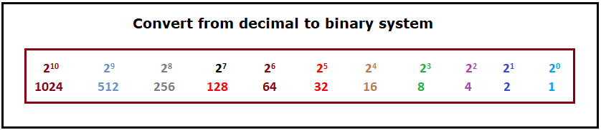

**Example: Convert 74 (decimal number) to binary number.**

From above picture we can get 74 from adding [64 + 8 + 2] so we added below these numbers 1 and the remain numbers between them 0; we get **1001010**

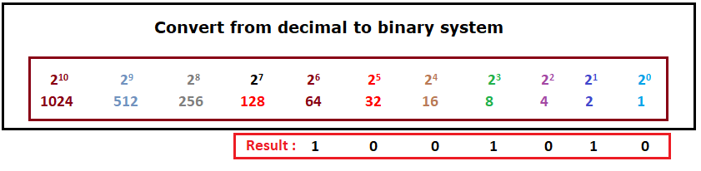

**Example: Convert 27 (decimal number) to binary number.**

From above picture we can get 27 from adding [16 + 8 + 2 + 1] so we added below these numbers 1 and the remain numbers between them 0; we get **11011**

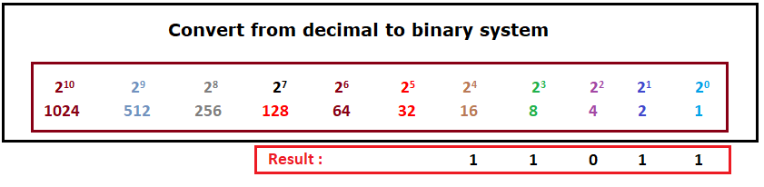

**Example: Convert 1011101 (binary number) to decimal number. We get 93**

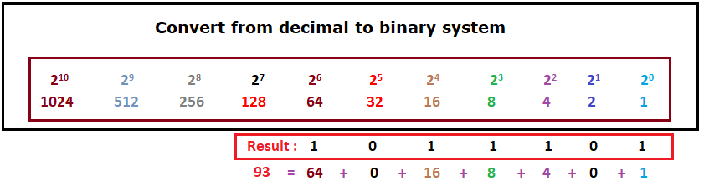

**Example: Convert 11101 (binary number) to decimal number. We get 29**

